Cleachtas na Scoile maidir leis an gCianfhoghlaim

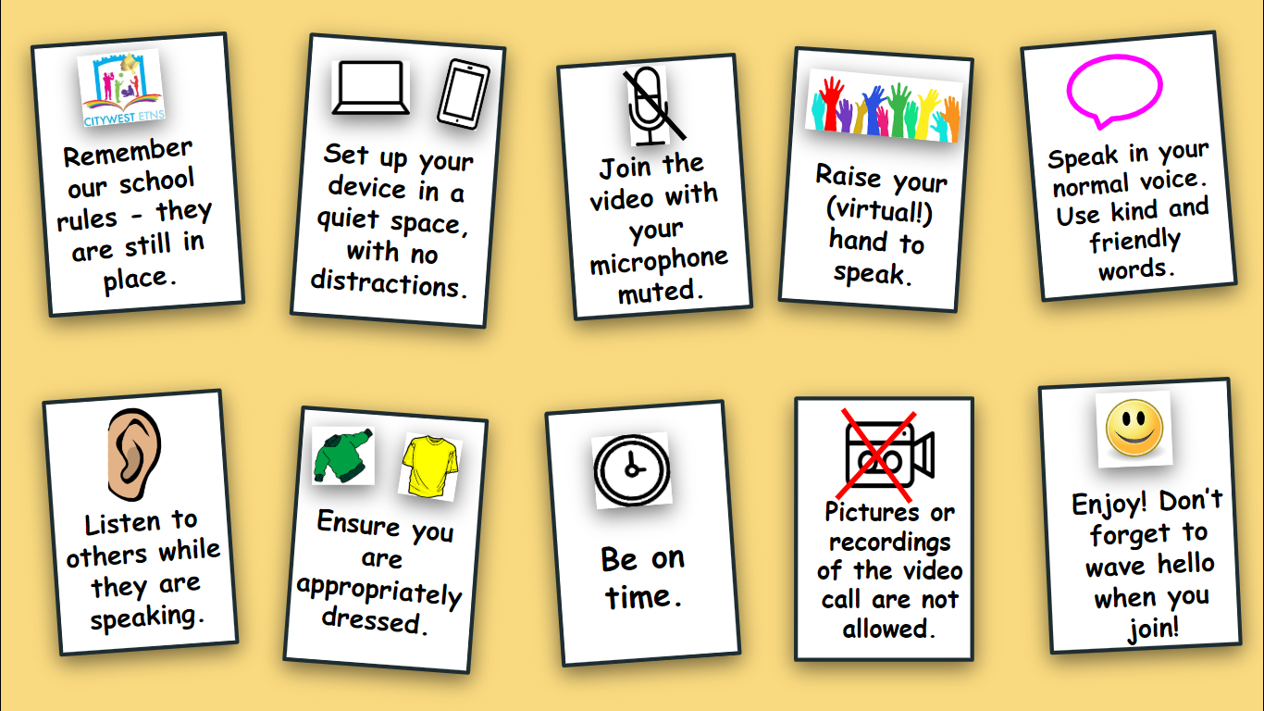

Aims and Rational
The aim of this document is to provide guidance to parents and pupils on what is best practice when using online platforms.
Gaelscoil Charman has introduced Aladdin Connect, Seesaw and where appropriate Zoom for online communication teaching and learning due to the distance learning demands of Covid 19 and it’s impact on schools
Seesaw has been chosen as our main remote teaching and learning tool.
This is a working document and is subject to change and updates.
Communication
The following methods will be used to communicate with pupils and parents/guardians
Aladdin for communication to parents/guardians from school and teachers. Phone calls will also be a feature on this contact.
Email addresses of school gaelscoilcharman@gmail.com and teacher emails for communication with individual teachers and school.
Whatsapp, Google Docs , email and Aladdin for contact and sharing between staff members
Seesaw for teacher/pupil communication
Zoom for staff meetings, assembly and some communication with groups of pupils.

General Guidelines for good online communication:
- Under no circumstances should pictures or recordings be taken of video calls.
- Staff, families and students are expected to behave in an appropriate, safe, respectful and kind manner online.
- It is the duty of parents/guardians to supervise children while they are working online and to ensure that any content submitted to their teacher is appropriate
- Staff members will communicate with pupils and their families via Aladdin or through an Seesaw and emails
- Any electronic forms of communication will be for educational purposes and to allow for communication with families.
- Students and staff will communicate using tools which have been approved by the school and of which parents have been notified (Seesaw, Zoom email )
- For video/Zoom calls, parental permission is implied, as the link to a video call will be communicated via Aladdin. Essentially, by virtue of the pupil logging on to the call, permission is assumed.
- For security reasons, passwords or codes will be provided to families, where applicable.
- Communication may only take place during normal school hours
- The normal school calendar will apply
- Teaching and learning for SEN will continue as remote learning in so far as possible.
- The following school policies apply to remote teaching and learning
- Code of behaviour
- Anti Bullying Policy
- Acceptable Use Policy

- Gaelscoil Charman cannot accept responsibility for the security of online platforms, in the event that they are compromised.
Best Practice for Students when using Seesaw and Zoom
- Activities should be completed on Seesaw and returned to teacher on Seesaw.
- Parents can photograph work/documents an attach in an email back to teacher if that is the preferred option.
- Do not post personal details online….see AUP policy
- Parents and guardians should supervise the work being posted on Seesaw to ensure that the content is appropriate.
- Dress appropriately for Zoom meetings and join from an appropriate area in the house. Be aware of noise and other people around you.
- Classroom rules apply when at Zoom meeting…no drinking or eating , and be respectful of other people.
- When on Zoom mute the microphone when you are not speaking and give others a chance to join in.
- Be kind and friendly when speaking on Zoom.
- Only use the keyboard for typing something relevant to the discussion.
- It is not permitted to take pictures or to record video calls.
Guidelines for Parents and Guardians
Parents /Guardians are responsible for the supervision of pupils while using online platforms.
Parents should check work being sent via Seesaw or email to ensure that it is appropriate.
Ensure that pupils are on time for video call giving time before the call so that the staff can verify details.
Make sure that your child is familiar with the software in advance. Children should be able to mute/unmute and turn the camera on and off.
Should there be any breaches of the above guidelines the communication will discontinue and parents will be receive a report of the incident.
For detailed information on GDPR please
https://zoom.us/privacy
https//web.seesaw.me/gdpr

